Retail
A data analysis of 100,000 Olist e-commerce transactions covering revenue, delivery, satisfaction, and customer segmentation.
By Tisetso Letuka

Executive Summary
- Revenue grew 20.1% year-over-year. November Black Friday spike averaged +55% above baseline inventory should scale up in October.
- 93.2% of orders arrive before the promised date. The platform deliberately under-promises by ~12 days. One state (Amazonas) averages 9 days late and needs logistics review.
- Late delivery directly reduces satisfaction scores by 2.02 points. Closing the 6.8% late delivery gap is the single highest-impact action for improving customer ratings.
- Champions are 8.6 % of customers but generate 17.5% of revenue. A targeted retention programme for this segment protects disproportionate revenue at low cost.

Revenue and Growth
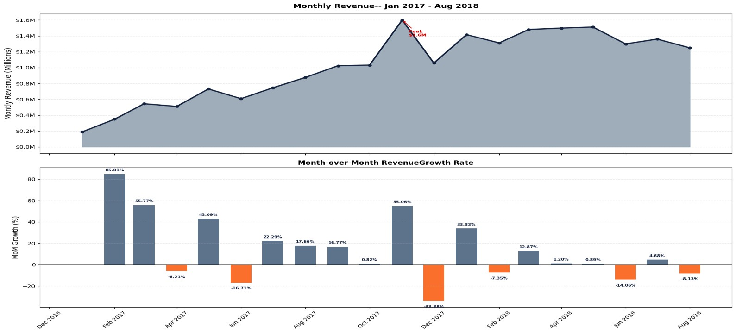
Overall, monthly revenue shows strong upward growth across the observed period, with signs of stabilisation as the platform matures.
A pronounced spike occurs in November 2017, where revenue reaches R$1.6M (+55% month-on-month), followed by a sharp decline in December, indicating a clear Black Friday effect driven by demand pull-forward rather than sustained growth.
Operationally, this suggests the business is highly sensitive to promotional events, with revenue concentration around key campaigns and less consistent baseline demand outside these periods.
Recommendation:
The business should optimise Black Friday and similar campaigns for maximum value extraction (inventory planning, pricing strategy, logistics readiness) while simultaneously investing in strategies that smooth demand across the year (e.g., smaller recurring promotions, customer retention programs, and diversification of peak periods) to reduce overreliance on single-event revenue spikes.

Delivery Performance and Customer Satisfaction
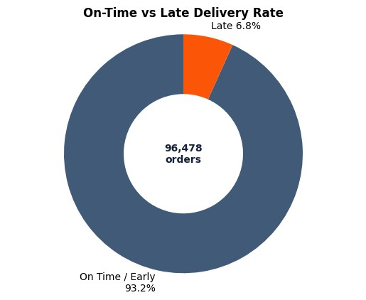

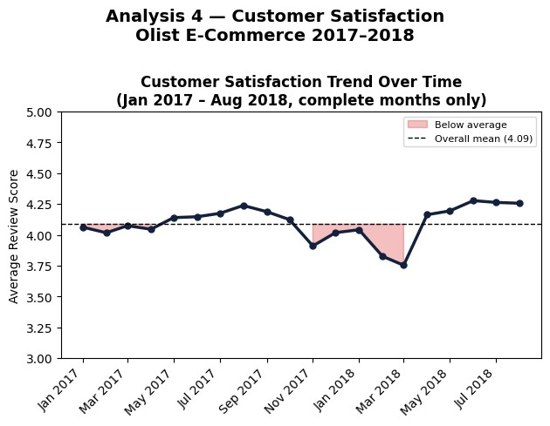
Overall, 93.2% of orders arrive on time or early, indicating very strong delivery performance with only 6.8% late deliveries.
The platform is clearly using an under-promise/over-deliver strategy, with a mean delay of 11.9 days, meaning customers typically receive orders nearly 12 days earlier than expected.
Amazonas (AM) stands out as the only outlier, averaging +9.0 days late, reflecting structural logistics constraints rather than seller underperformance.
The delay–satisfaction relationship shows that late deliveries significantly damage customer experience (2.27 vs 4.29 average scores), but the overall weak correlation (-0.27) indicates delivery is important but not the sole driver of satisfaction. Notably, the satisfaction dip from Nov 2017–Mar 2018 coincides with the Black Friday revenue surge (+55% MoM), showing that volume spikes can strain operations and temporarily harm customer experience.
Recommendations:
- Adjust delivery estimates dynamically by region, especially for AM, to reflect realistic logistics and avoid preventable dissatisfaction.
- Maintain the under-promise strategy but tighten buffers to avoid excessive early delivery gaps that may hide inefficiencies.
- Prioritise reducing the 6.8% late deliveries, as even small improvements yield measurable gains in customer satisfaction.
- Address non-delivery drivers of dissatisfaction (e.g., low-performing product categories and seller quality), since delivery alone does not explain most of the variance in review scores.

Customer Segmentation
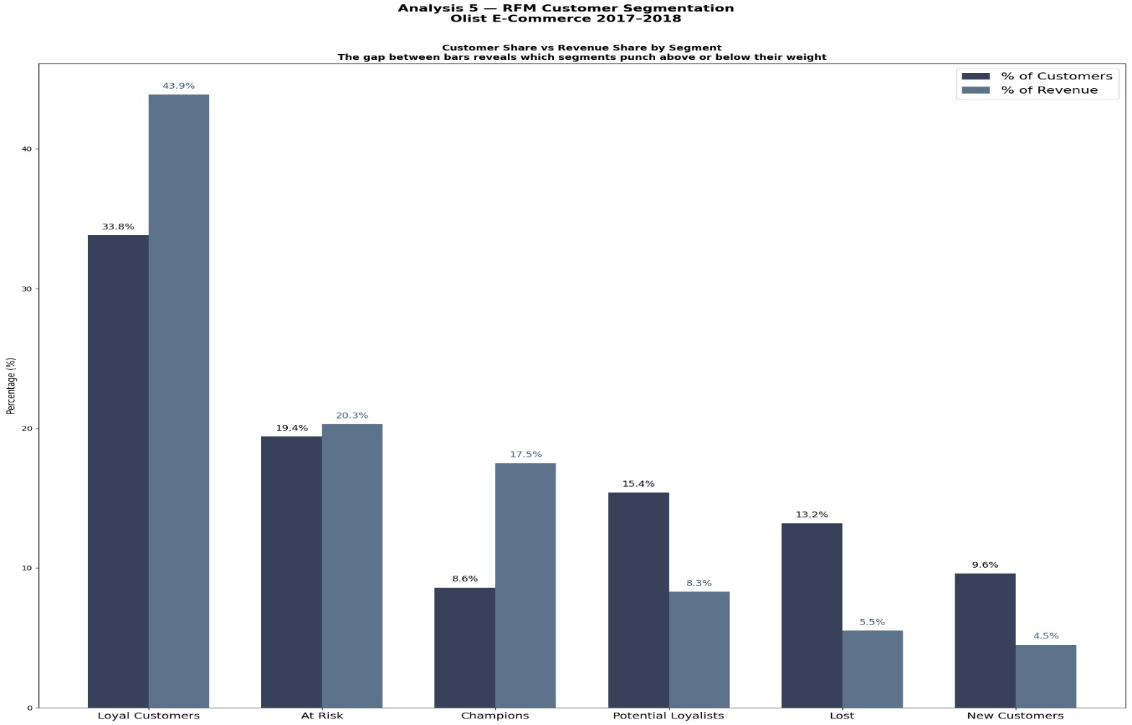
Champions represent 8.6% of customers but generate 17.5% of total revenue, demonstrating a disproportionate contribution relative to their size.

The Lost segment is the largest by customer count at 13.2% of customers, representing infrequent, low-spending buyers who are unlikely to return without targeted intervention.

At Risk customers, who were once valuable but have not ordered recently, represent recoverable revenue and a key opportunity to win back spending that might otherwise be lost.

Recommendations:
- Launch a targeted retention program for Champions with personalised outreach, loyalty rewards, and priority service to protect high-value revenue.
- Implement first-order interventions or onboarding campaigns to convert one-time Lost customers into repeat buyers.
- Run win-back campaigns for At Risk customers using personalised discounts, reminders of past purchases, or early access to new products to recover revenue before it transitions to Lost status.

